**LIDAR Sensor (Light Detection and Ranging)**

A **LIDAR sensor** is a device that measures distances by emitting laser light and analyzing the reflected signals. It is commonly used in robotics for navigation and obstacle detection.

**How It Works:**

1. The sensor emits a laser beam toward an object.
2. The beam hits the object and reflects back to the sensor.
3. The sensor calculates the distance based on the time taken for the light to return (time-of-flight principle).

**Key Features:**

* **360-Degree Scanning**: Many LIDAR sensors (e.g., on TurtleBot3) rotate to scan the environment around the robot.
* **High Accuracy**: Measures distances with precision, making it ideal for detecting walls, obstacles, or other objects.
* **Works in Low Light**: Since it uses lasers, LIDAR can operate in the dark, unlike cameras that rely on ambient light.

**Applications in Your Project:**

* **Wall Following**: The LIDAR detects the distance between the robot and the walls on its sides.
* **Obstacle Detection**: It identifies objects directly in front of the robot, helping it stop or re-route.

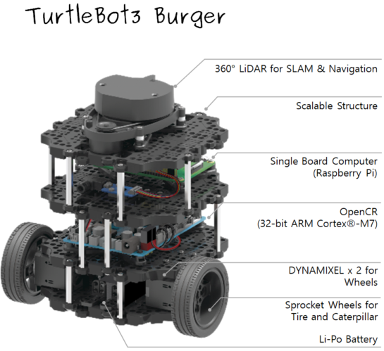

**PID Controller (Proportional-Integral-Derivative Controller)**

A **PID controller** is a control algorithm used to adjust a system's behavior by minimizing the error between a desired state (e.g., following a line) and the current state.

**Components of PID:**

1. **Proportional (P)**:
   * Responds to the **current error**.
   * The larger the error, the stronger the corrective action.
   * Example: If the robot is far from the line, it makes a large steering adjustment to align with it.
2. **Integral (I)**:
   * Accounts for **past errors**.
   * Helps eliminate long-term drift by considering accumulated error over time.
   * Example: If the robot has been consistently off-center, it adjusts to correct this drift.
3. **Derivative (D)**:
   * Predicts **future error** by considering the rate of change.
   * Smooths out sudden movements and prevents over-correction.
   * Example: If the robot starts deviating too quickly, it gently slows down the adjustment.

**Formula:**

The output of the PID controller is:

Output=Kp⋅Error+Ki⋅∫Error+Kd⋅d(Error)dt\text{Output} = K_p \cdot \text{Error} + K_i \cdot \int \text{Error} + K_d \cdot \frac{d(\text{Error})}{dt}Output=Kp​⋅Error+Ki​⋅∫Error+Kd​⋅dtd(Error)​

Where:

* Kp,Ki,KdK_p, K_i, K_dKp​,Ki​,Kd​ are tunable parameters (gains) that determine the influence of each term.
* Error = Desired state - Current state.

**Applications in Your Project:**

* **Line Following**:
  + The error is the difference between the green line’s center and the robot’s camera center.
  + The PID controller adjusts the robot’s steering angle based on this error.
  + This ensures smooth, accurate movement along the line.

**Comparison of Roles:**

| **Aspect** | **LIDAR Sensor** | **PID Controller** |
| --- | --- | --- |
| **Function** | Senses the environment (distance to walls/obstacles). | Adjusts robot behavior (steering, speed) based on error. |
| **Purpose** | Provides input data for wall-following logic. | Processes error to compute precise movement commands. |
| **Example Use Case** | Detects a wall 1m away from the robot. | Corrects robot’s alignment when drifting off a line. |